Plate Boundaries Questions Name___________________
Plate Tectonics Group # Date_______________

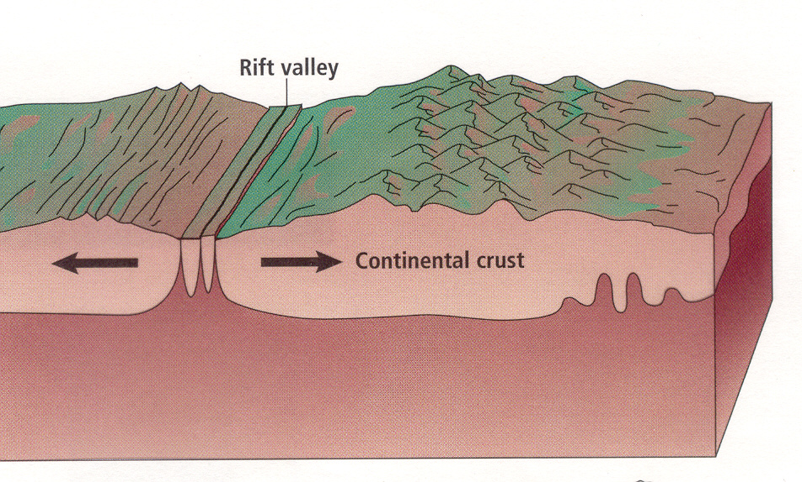

Divergent move which cause .

Which type of plates are shown?

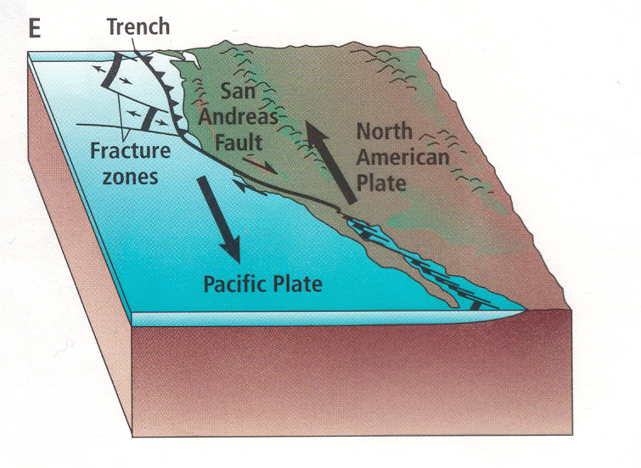

Divergent move which cause .

Which type of plates are shown?
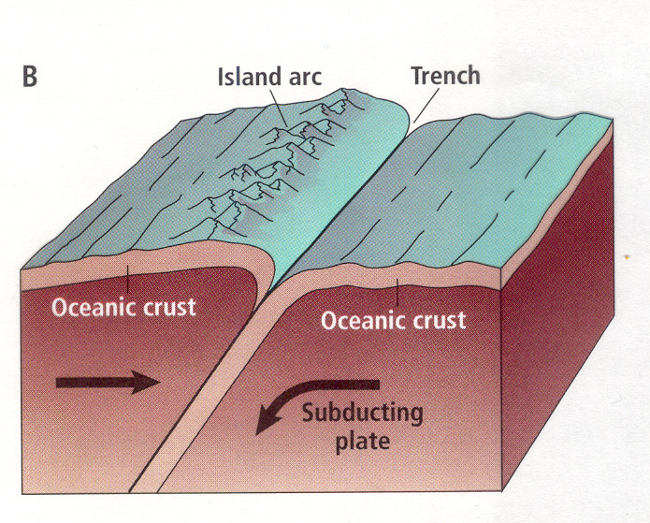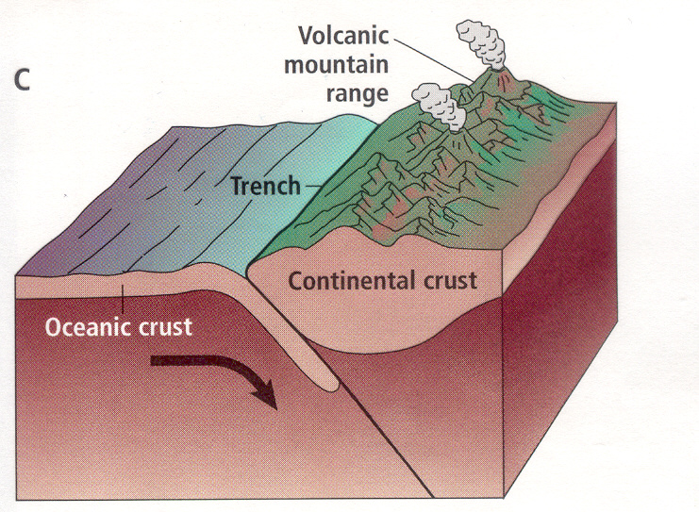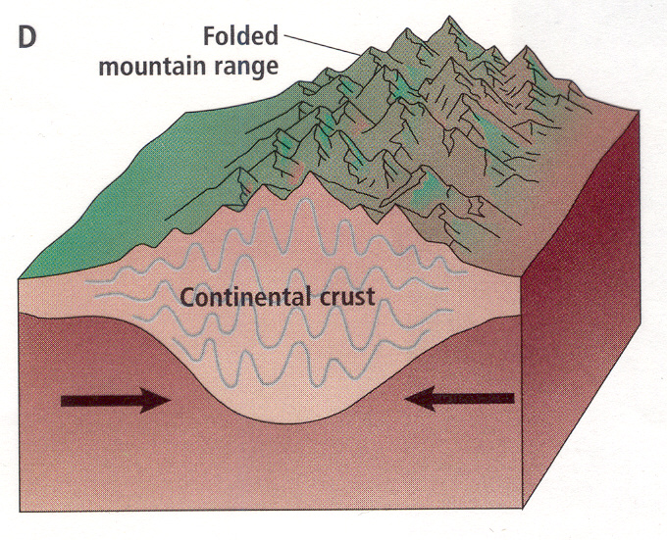

Convergent move which cause .

Which type of plates are shown ?

Plate Boundaries Questions Name___________________
Plate Tectonics Group # Date____________________

- Which of the above boundaries can produce earthquakes? At which of those is the largest earthquakes produced? (p 103)

- Which of the above boundaries can produce volcanoes?

- At which of the above boundaries is sea floor created?

- At which of the above boundaries is sea floor destroyed?

- What are the three sub-types of convergent plate boundaries?

- What is the most studied transform fault in the world?

- Write your own question based on plate boundaries here.

